NJR2145J 10 GHz pre-amplifier adaptation and construction

Gary Lopes – WA6MEM
gary@wa6mem.com

The pursuit of perfection is a never ending process for the microwave enthusiast. The very notion that you can eek another dB of gain or reduce the noise figure 0.1 dB keeps all of us looking for the perfect design.

The intent of this paper is to provide guidance for the conversion of the popular NJR2145J TV LNB to the 10 GHz amateur band to be used as a receiver pre-amplifier and the adaptation of the amplifier from wave guide input to an SMA connector interface. The methods used for this work employ basic hand tools and a drill press. I hope to show that most anyone can enjoy and be successful building and modifying microwave equipment.

I built my present 10 GHz radio a several years ago and had employed a receiver pre-amplifier that was less than optimal. The gain was ok but the noise figure was approaching 2 dB and I knew something better was available that would allow me to hear that elusive carrier that was just out of the noise.

I had acquired a surplus NJR2145J unit and based on the published performance specifications it seem to be the perfect replacement for my old pre-amplifier. The modifications to the circuit seemed simple but it used a wave guide interface. Because my 10 GHz radio was rather compact and used coax interconnects I had no room for a “large” WR42 transition. I had to have a slim, coax connected, pre-amplifier.

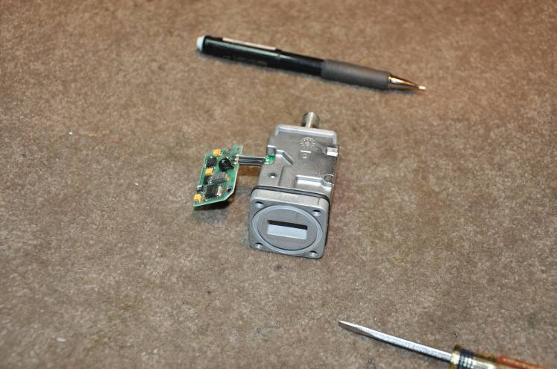
To begin the conversion and modification process, the following steps were completed:

1. Remove nut on the F connector and slide the metal case off.

2. Remove the die cast lid. Save the lid! You will need it for the finished product. Unsolder, remove and discard the rectangular DRO can on the backside. Remove the mounting screws for the small DC power PCB on the other side of the unit and lift out of the way. This will allow removal of the DRO.

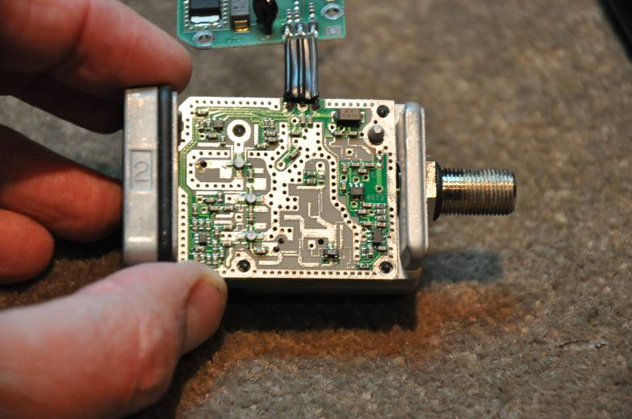

3. Remove the PC board and attached DC power PCB from the main housing.

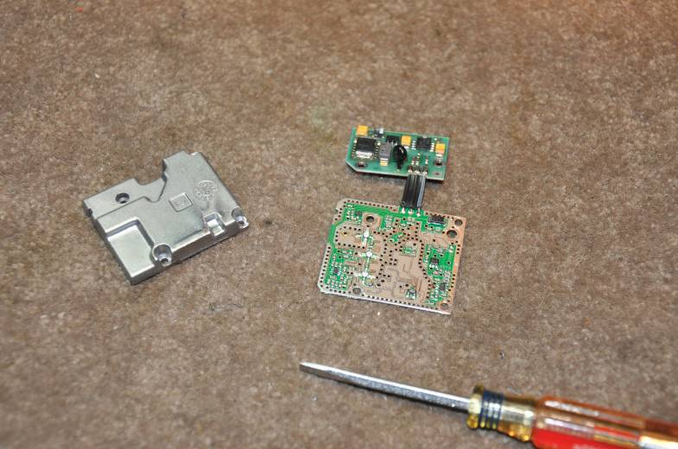

Prepare an aluminum 2.75” x 1.25 x 0.125” plate to be used for mounting the amplifier.

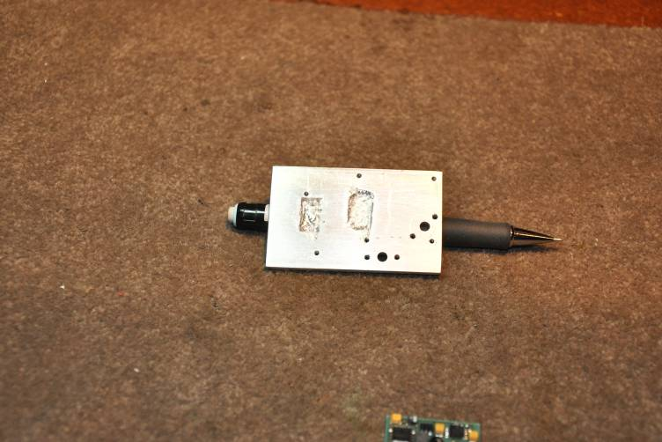

4. Position the main pre-amplifier board on the aluminum and mark the four mounting screws locations using the die cast lid as guide.

5. Drill and tap the four 4-40 size holes that will be used for mounting the board and the die cast lid to the aluminum plate. Also, drill two 4-40 holes for the power supply board to be mounted to the side of the amplifier.

6. There are two areas of protruding wires on the backside of the pre-amplifier board that require a corresponding “well” on the aluminum plate to prevent these connections from shorting. I wish I owned a mill to make this step a bit more elegant with a corresponding aesthetically better result but I don’t. I used a Dremmel tool with a small carving bit to hog out the appropriate areas required to allow clearance of the connections on the board.

7. Mount the pre-amplifier board to the aluminum plate with screws used for the die cast cover.

8. Remove the three terminal component marked R1E from the board. Remove the circuit traces highlighted in green in the photo.

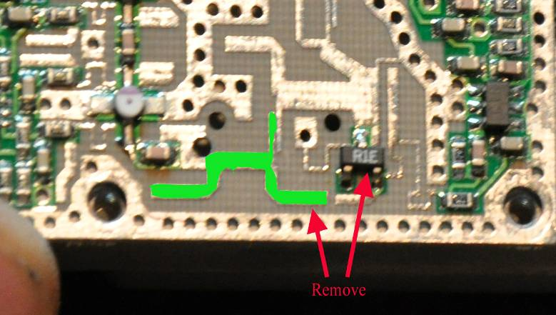
9. Drill two 0.052” (#55 drill) holes using the two holes already on the board as guides. These will be used for the SMA connector center pins.

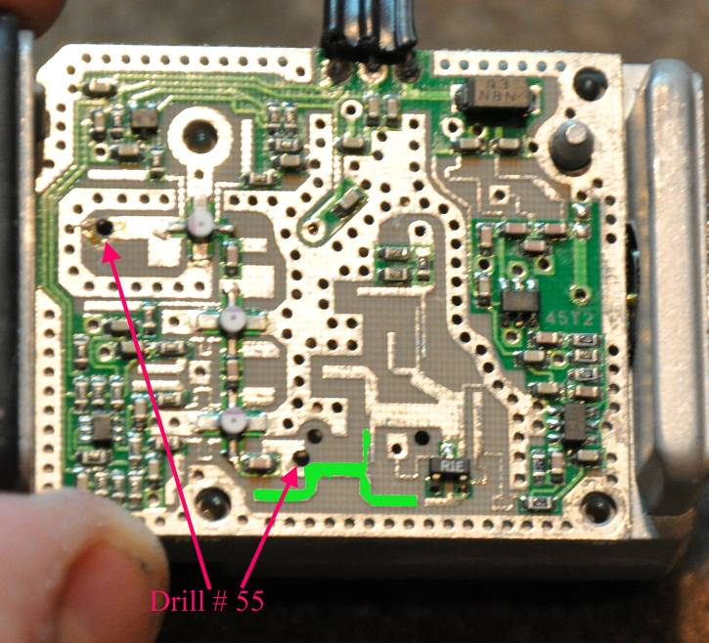

10. Mount the board on to the aluminum plate. Mark the position of the two #55 drill holes on the aluminum plate.

11. Remove the board from the aluminum plate and drill two 0.1610” (#20 drill) holes through the aluminum plate on the previously marked spots.

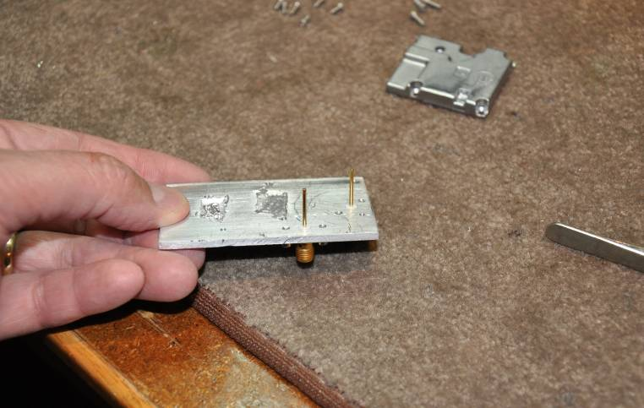

12 Insert two SMA female connectors in the two holes. The connectors should be the type with the extended Teflon insulator body. Mark the positions of the connector mounting holes. Drill and tap two 4-40 holes for each connector as shown.

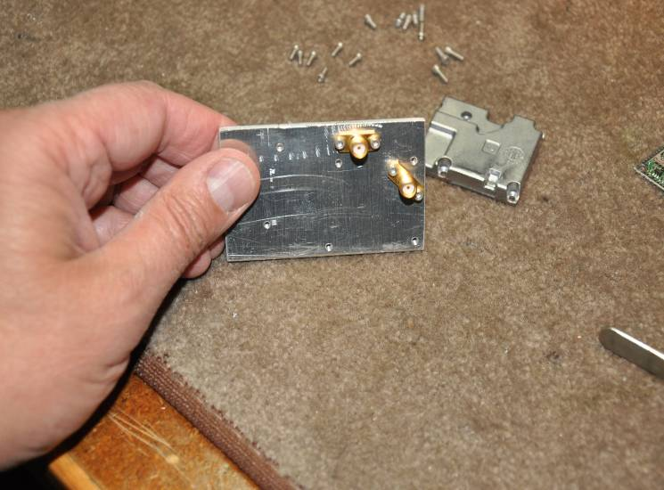

13. After the connectors are mounted to the aluminum plate with the mounting screws, use a flat razor blade to trim the excess Teflon around the center pin of the connector. The top of the Teflon should now be flat with the surface of the aluminum plate.

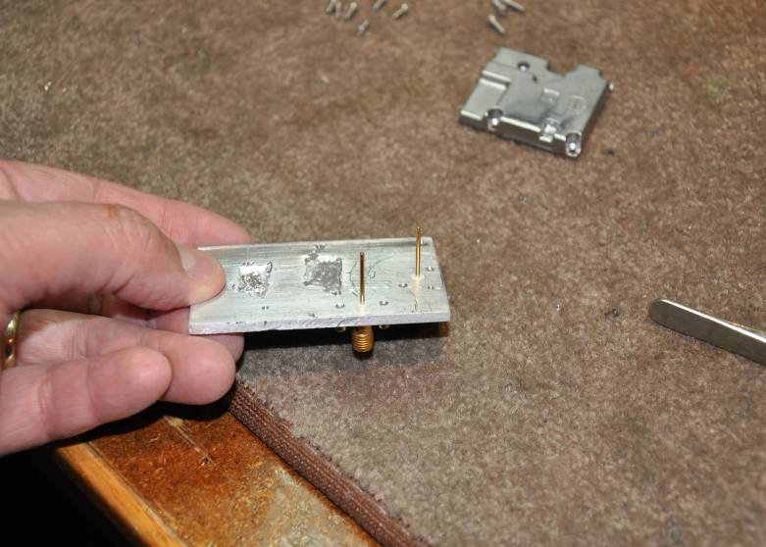

14. Mount the pre-amplifier to the aluminum plate by aligning the two connector pins to the two #55 holes. Carefully slide the SMA center pins through the holes and seat the pre amplifier flat on the aluminum plate.

15. Attach the pre amplifier to the aluminum plate with the four mounting screws to insure the amplifier is flat against the aluminum plate.

16. Solder the two SMA center pins to the amplifier input and output connections. Remove the excess center pin sections above the soldered connection point.

17. DC power for the amplifier is supplied to the connection where the F connector attached to the board. You can drill a hole and use a DC feed through pin as I did or simply solder a wire to the DC point and bring it out under the die cast lid. Be sure and cut a notch in the lid so the DC feed wire is not pinched.

18. Remove the screws from the amplifier and install the die cast lid using the four assembly screws. Attach the power supply board using the two mounting holes.

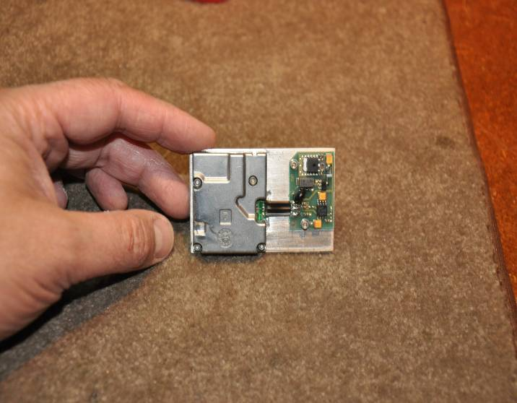

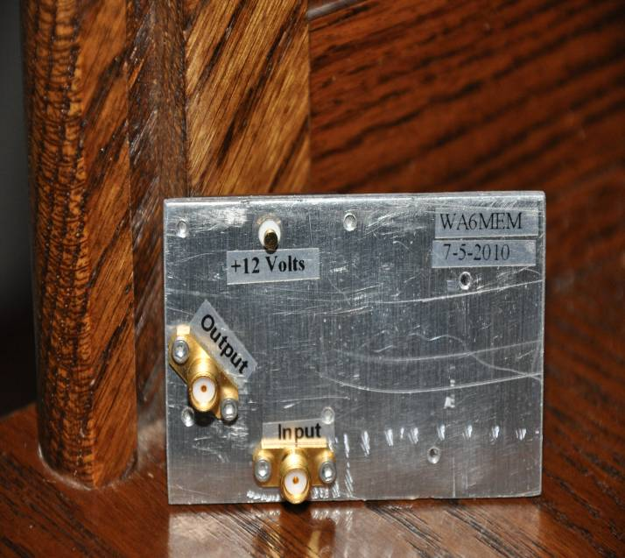

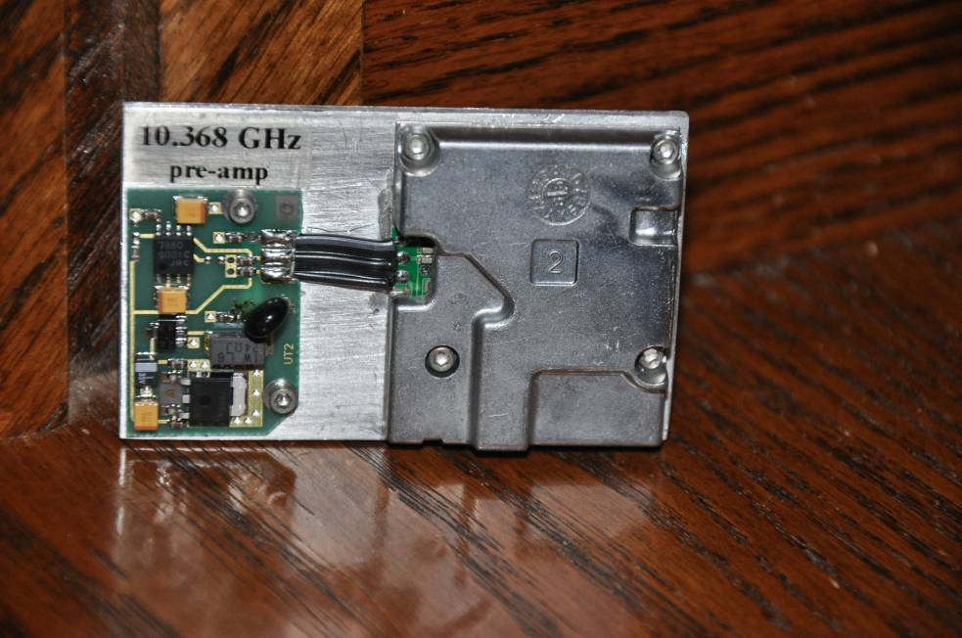

That’s all there is to it! When you’re done you have a small and clean 10.368 GHz receiver pre amplifier.

The preamp has an internal regulator that will take from 11V up to 30V. It works nicely on 12VDC without an external regulator.

The measured performance was as expected. A measured 32 dB of gain and a 0.94 dB noise figure was achieved. That should give me just what I need to hear that weak one just out of the noise.

This is a great project that can be completed in a few hours and simple tools.

I would like to recognize Frank Kelly, WB6CWN, for his encouragement and guidance in perusing this project.

